Just sample text.

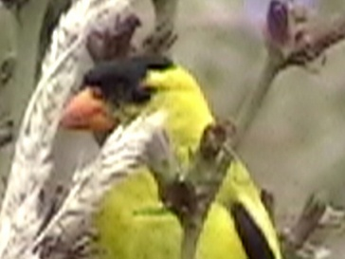
Picture one of an August Goldfinch
Coming back again after save and exit.

More stuff

